Final Project Design Phase
Computer Science - Week 11
Oct 3, 2026 - Version 0.0.4

For complete instructions and project ideas, refer to the assignment in Canvas. Specifically, review the final project requirements before you continue below. If you have not reviewed the project requirements in Canvas (you might have to go to the modules view and check the current or past week's content), you will not be able to properly complete the parts below. In addition, it may be helpful to review the information on this Drafter documentation page.

0) Project Planning and Preparation
Successful programmers spend time planning before they begin coding. After reviewing the project requirements, answer the following questions to help guide your design and development process.
- What concepts from class or previous assignments might help you complete this project? Which programming concepts (loops, conditionals, lists, classes, etc.) do you expect to use? What programming skills do you want to improve while completing this project?
I expect to use most of the concepts covered in the class, including dataclasses, lists, loops, conditions, a lot of functions, unit tests and drafter components. The skills I want to improve are creating a complex Drafter program, improving user-interface, and structuring a multi-page app.

- Which parts of the project do you expect to be the easiest for you? The hardest? Why?
The easiest parts will be the math formulas for distance, cost, etc. because they are simple arithmetic. The hardest parts will be finding the best route, as that involves a computationally complicated algorithm, and testing the routes because I don’t yet know how to unit test pages.

- Even though you have not yet designed the final project, estimate which tasks will likely require the most time and effort? Which features or components should be implemented first?
I expect most of my time and effort to go towards the brute-force best route finder, and input validation, because bad input will be a huge problem for the site. I will also spend some effort testing the routes and cleaning the code. I will first implement the dataclasses and the best route helper functions, with unit tests. Then, I will work on building a basic Drafter site with the home page and the results page.

- What distractions might interfere with your work and how will you minimize them? What resources will you need available while working? What questions, if any, do you still have about the assignment requirements?
My main distractions will be my other classes that take up most of my time. Furthermore, the fact that we are allowed to use AI might hinder me from actually becoming a better programmer. I will minimize these by scheduling fixed work hours for the project, and take the time to understand the code output by LLMs. Resources I’ll need include the program requirements, my project idea, office hours, the course textbook, and Drafter documentation.
I question whether or not new libraries count as advanced techniques. For instance, my program will be making use of the itertools library, which is not something we covered in class. So how do I thoroughly document this?

1) Site Diagram
Create a mock-up of your planned website. We suggest you make the mockup on paper, although you can also use software like PowerPoint or Slides to make a mockup. There is other design software that could also be used, but we strongly encourage you to keep it simple. Do not spend more than 15-30 minutes detailing the mock-up. Your goal should be to make a very quick and dirty diagram, to show that you have some kind of idea.

We recommend drawing each page as a rectangle, and laying out the text, buttons, and other components inside. Then, use arrows to indicate links between pages. Label each page the way you will name each function, and then put labels on the arrows to indicate what the button links. Also write down any parameters that should come into the pages.

In addition to the pages and routes, write down what fields your `State` will have, both their names and types. Think clearly about what data will need to be persistent across the entire website.

Add photo(s) or screenshot(s) of your website mock-up and labeled diagram on the next page.

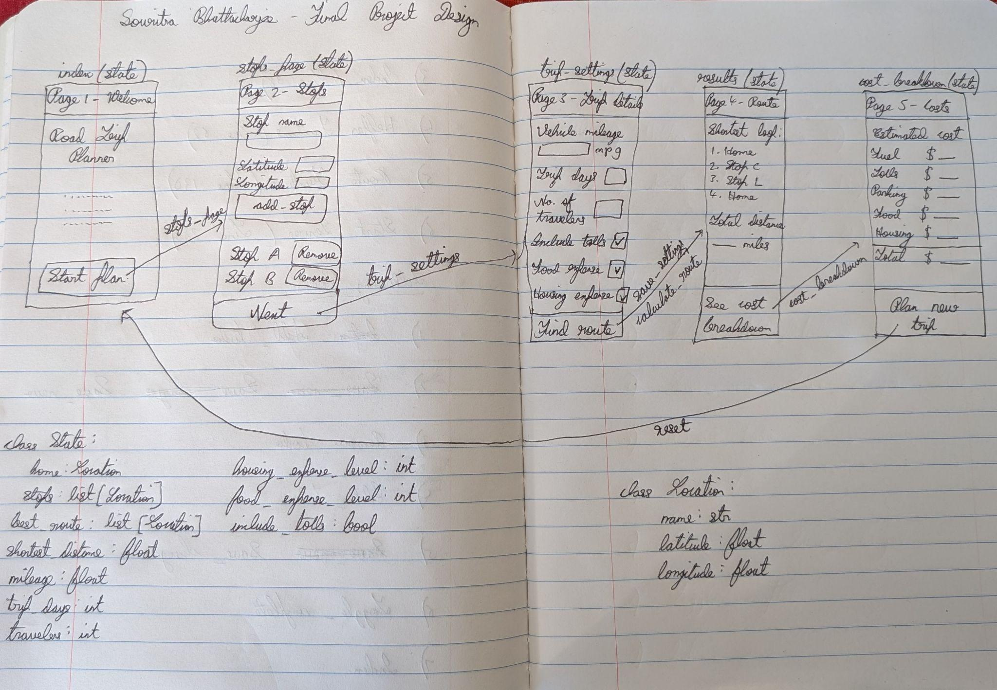

2) Implementing Requirements

This table should serve as a draft for how you will implement the requirements into your final project. You may change your ideas later on, but your final site must fulfill all the requirements.

Requirement | Implementation
Purpose/Functionality  A 1-2 sentence description of the purpose or functionality of your site | The site will optimize multi-stop road trips by producing the shortest distance route and breaking down the costs involved.
State Dataclass Attributes  Minimum of 4 attributes, one of which must be a list/dict of instances of your second dataclass.  Briefly describe each attribute, its type, and how it will be meaningfully modified throughout the site. | - stops: list[Location] - appended to in add_stop and removed from in remove_stop  - mileage: float - set from TextBox in save_settings and is divided by route distance to get fuel use  - trip_days: int - set in save_settings, and used to calculate parking, food, housing costs  - travelers: int - set in save_settings, and scales the food/housing costs  - food_expense_level: int - set from SelectBox (1-5) in save_settings, and picks the food cost rate  - housing_expense_level: int - set from SelectBox (1-5) in save_settings, and picks the housing cost rate  - Include_tolls: bool - set from CheckBox in save_settings, and decides whether tolls are added to the cost  - best_route: list[Location] - processed in calculate_route with the shortest order found  - best_distance: float - processed in calculate_route with the route’s total length
Second Dataclass  Your second dataclass, including its attributes, their types, and how they will be meaningfully modified (if they are modified) | class Location:  name: str  latitude: float  longitude: float  Location objects would be created in add_stop and deleted in remove_stop, but the instances will not be modified after creation.
Routes (minimum 7)  The names of your route functions | - index  - stops_page  - add_stop  - remove_stop  - trip_settings  - save_settings  - calculate_route  - results  - cost_breakdown  - reset
Pages (minimum 5)  A brief description of the pages in your site | - Welcome (index) - introduces the site  - Stops (stops_page) - allows users to create a list of stops, adding and removing stops  - Trip settings (trip_settings) - collects trip details like days, travelers, food/housing levels, tolls, car mileage  - Route results (results) - shows the best route and its total distance  - Cost breakdown (cost_breakdown) - breaks down total cost into fuel, parking, tolls, food/housing
User Input (minimum 3)  Description of user input components (TextBox, TextArea, CheckBox, or SelectBox) and their purposes  For more information on these input types, see Drafter Documentation. | TextBox:  - Stop name  - Latitude coordinate  - Longitude coordinate  - Vehicle mileage  - Trip days  - Travelers  SelectBox:  - Food level (1-5)  - Housing level (1-5)  CheckBox:  - Include tolls
If Statements (minimum 3)  Brief description of what will be evaluated in your if statements and how they will meaningfully change the logic of the site | - Validating a new stop (add_stop): checks the stop name isn’t blank, the coordinates are numbers, and stop names are unique; raises error otherwise  - Validating trip settings (save_settings): checks that mileage, days, travelers are positive numbers; rejects them otherwise  - Comparing routes (calculate_route) - inside the loop, if an ordering produces a shorter distance than the best found so far, it replaces it  - Counting tolls (cost_breakdown): checks if include_tolls is True, and adds tolls to the total cost in that case  - Stop count (calculate_route): checks if there are at least 2 stops in the route; causes error otherwise
Loop (minimum 1)  This loop must iterate over the list/dict of dataclass instances in your State attribute.  Description of this loop and why it is meaningful to the site | - Route length (iteration over Location instances) - accumulates distance between consecutive stops on a route  - Brute-force search (iteration over list of Location instances) - finds the minimum distance route after looping through each permutation  - Displaying stops (iteration over list of Location instances) - shows each stop’s name and coordinates with a remove button

LLM Conversation
If you used an LLM in any part of this work, copy and paste every part of that conversation below. Otherwise, you may be given a zero for the assignment. Obviously, these words will not all be yours, and this is the exception to the requirement at the top of this assignment that all responses be in your own words. If you did not use an LLM to assist you in this assignment, simply say so below.
I want to ensure that my project will fulfill all the requirements. explain how my site would comply the following requirements:
Requirement
Purpose/Functionality
State Dataclass Attributes
Minimum of 4 attributes, one of which must be a list/dict of instances of your second dataclass.
Second Dataclass
Your second dataclass, including its attributes, their types, and how they will be meaningfully modified (if they are modified)
Routes (minimum 7)
Pages (minimum 5)
User Input (minimum 3)
Description of user input components (TextBox, TextArea, CheckBox, or SelectBox) and their purposes
If Statements (minimum 3)
Loop (minimum 1)

Purpose/Functionality
Your site is a road trip planner. It takes a home point and a set of destination coordinates, uses brute-force Traveling Salesman to find the shortest round trip, and estimates the trip’s total cost (fuel, tolls, parking, food and housing). It helps users plan fuel-efficient trips and set a realistic budget.

State Dataclass Attributes (9 attributes)
Attribute | Type | How it is meaningfully modified
stops | list[Location] | Appended to in add_stop and removed from in remove_stop. Emptied by reset.
mpg | float | Set from the TextBox in save_settings. It is later divided into the route distance to get fuel use.
trip_days | int | Set in save_settings. It scales the parking and food/housing costs.
travelers | int | Set in save_settings. It scales the food/housing costs.
food_level | int | Set from a SelectBox (1–5) in save_settings. It picks the food cost rate.
housing_level | int | Set from a SelectBox (1–5) in save_settings. It picks the housing cost rate.
include_tolls | bool | Set from a CheckBox in save_settings. It decides whether tolls are added to the cost.
best_route | list[Location] | Overwritten in calculate_route with the shortest ordering found.
best_distance | float | Overwritten in calculate_route with that route’s total length.
home is a Location and could also be a state field. The state also has a message: str for validation errors, which is changed in several routes.

Second Dataclass
python

@dataclass
class Location:
name: str # label shown to the user, e.g. "Philadelphia"
x: float # x coordinate (miles on the grid)
y: float # y coordinate (miles on the grid)
Location objects are created in add_stop (and for home in save_settings) and deleted in remove_stop. Their fields aren’t changed after creation, because the shortest-route search needs fixed coordinates.

Routes (10)
index, stops_page, add_stop, remove_stop, trip_settings, save_settings, calculate_route, results, cost_breakdown, reset.

Pages (5)
- Welcome (index): explains the site and links to the planner.
- Stops (stops_page): shows the form to add a stop and the current list of stops, each with a remove button.
- Trip settings (trip_settings): collects the mpg, days, travelers, food/housing levels and the tolls option.
- Route results (results): shows the best route in order and its total distance.
- Cost breakdown (cost_breakdown): shows fuel, tolls, parking, food and housing, plus the total.

User Input (8 components across 3 types)
- TextBox: stop name, x, y, mpg, days and travelers.
- SelectBox: food level and housing level, each 1–5.
- CheckBox: “Include tolls”.
Together they supply everything the route search and cost estimate need.

If Statements (5+)
- Validating a new stop (add_stop): checks the name isn’t blank, the coordinates are numbers, and the name isn’t a duplicate. If any check fails, an error message is set and the stop isn’t added.
- Stop count (calculate_route): if there are fewer than 2 stops, it asks for more. If there are more than 8, it refuses to run, because brute force becomes too slow.
- Validating settings (save_settings): if mpg, days or travelers are zero, negative or non-numeric, it rejects them and keeps the old values.
- Tolls (estimate_costs): if include_tolls is True, tolls are added to the total. Otherwise they’re zero.
- Comparing routes (best_route): if the current ordering is shorter than the best found so far, it replaces it. This is the core of the algorithm.
A guard in results and cost_breakdown also redirects the user back if no route has been calculated yet.

Loop (3+, all over Location instances)
- Route length (route_length): for stop in route: accumulates the distance between consecutive stops using each stop’s x and y. This is the main use of the dataclass attributes, and it’s the step the brute-force search repeats for every ordering.
- Brute-force search (best_route): loops over each permutation of state.stops, computes its length, and keeps the shortest. This is the heart of the Traveling Salesman solution.
- Displaying stops (stops_page): for stop in state.stops: shows each stop’s name and coordinates, with a remove button for each.
All three loops go through the list in State, so they satisfy the requirement that the loop must iterate over the dataclass list.

Two things to watch
- Constants: keep gas price, parking per day, toll rate and food/housing rates as ALL_CAPS global constants. They aren’t state, and the requirement allows them.
- Permutations: itertools.permutations is outside what we covered. Either document it thoroughly in a comment, or write the permutation logic yourself with recursion to avoid the question entirely.

Final Submission
When you are finished, download this file as a Word Document (docx) and upload the file to the appropriate assignment on Canvas.

